Smart navigation robotic vehicle
Abstract:
The Smart Navigation Robotic Vehicle is designed to move safely and efficiently in environments where obstacles may appear unexpectedly. It uses ultrasonic sensors to continuously monitor its surroundings and detect obstacles in real time, enabling the robot to make quick decisions and select a path with maximum free space to avoid collisions. An Arduino microcontroller acts as the central control unit, processing sensor data and generating control signals for the motor driver to regulate motor speed and direction using Pulse Width Modulation (PWM) for smooth and stable movement. The vehicle supports multiple modes of operation, including autonomous obstacle avoidance, Bluetooth-based manual control, and voice-controlled navigation, which enhances flexibility and user interaction. The system features a modular and expandable design that allows easy integration of additional sensors, ensuring reliable performance even in dynamic environments. It is cost-effective, easy to implement, and suitable for applications such as autonomous delivery, surveillance and assistive robotics, with future scope for artificial intelligence-based path planning and smartphone-based real-time monitoring
Circuit diagram: 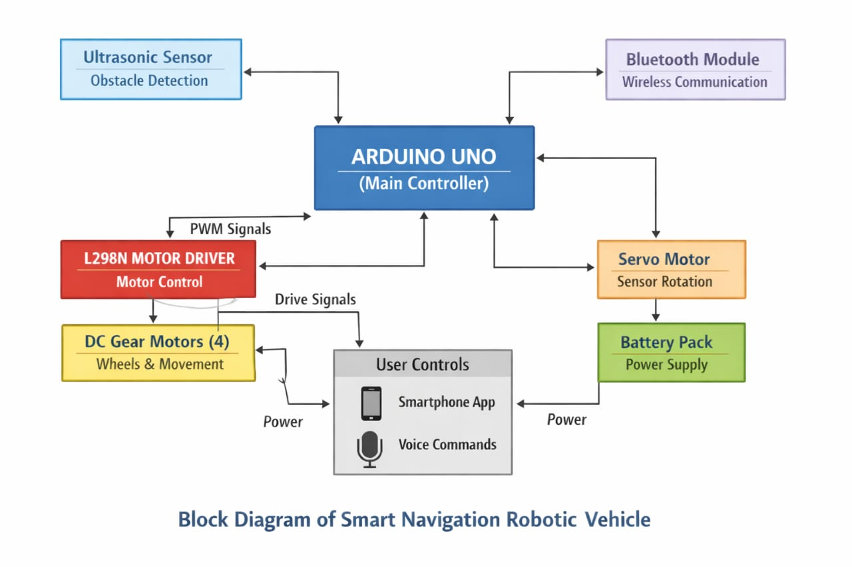
Working:
The Smart Navigation Robotic Vehicle is controlled by an Arduino UNO, which manages the sensors, motors, and Bluetooth communication. In autonomous mode, an ultrasonic sensor continuously detects obstacles in front of the robot. When an obstacle is found, the sensor mounted on a servo motor scan left and right, and the robot moves in the safest direction.
In manual mode, the robot is controlled using Bluetooth or voice commands from a smartphone. The Arduino processes these commands and controls the motor movement accordingly, while basic obstacle safety is maintained.
The L298N motor driver controls the direction and speed of the motors, enabling smooth and stable movement. This system allows the robot to operate safely in both autonomous and user-controlled modes.

